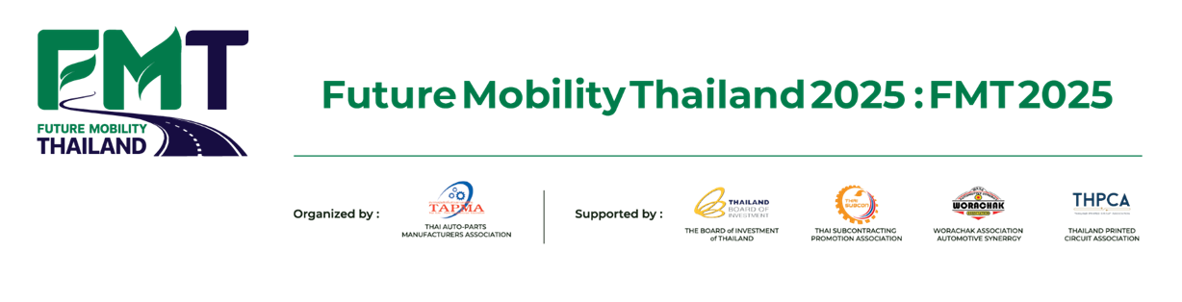

**FACT SHEET: Future Mobility Thailand 2025 : FMT 2025**

**"Driving Tomorrow: Innovating for a Sustainable and Connected Future"**

**1. Event Overview**

**Event Name:** Future Mobility Thailand 2025 (FMT 2025)

**Theme: "**Driving Tomorrow: Innovating for a Sustainable and Connected Future"

**Date: April 3-5, 2025**

**Venue:** Bangkok International Trade & Exhibition Centre (BITEC), Bangna, Bangkok

**Organizer:** Thai Auto Parts Manufacturers Association (TAPMA)

**Supporting Organizations:**

* Thailand Board of Investment (BOI)
* Thai Subcontracting Promotion Association
* Worachak Association Automotive Synergy

- Thailand Printed Circuit Association

**2. Key Highlights**

**✅ Opening Ceremony by the Minister of Industry**

**Keynote Speech: "**The Power of Parts: The Future of Thailand’s Auto Parts Industry" Government strategies to support the transition to EV and Smart Mobility

**✅ The Power of Parts Exhibition**

Over 100 exhibitors from Thailand and beyond showcasing innovations in EV parts, ADAS, advanced materials, and cross-industry applications

**✅ Business Matching & Joint Venture Negotiation**

* Facilitating partnerships between Thai parts manufacturers and global investors direct access to supply chains of major automakers and Tier 1-2 technology providers.

April 3rd: Business matching between automotive manufacturers and

parts manufacturers.

April 4th: "Joint Venture" matching event for companies seeking

investment in Thailand.

April 5th: Parts transform business matching for parts manufacturers

looking to expand into other Industries.

**✅ Future Mobility Conference**

Industry insights on global trends in auto parts, EVs, ADAS, and international market expansion for Thai manufacturers

**✅ Live Demonstrations of Future Auto Parts**

Next-generation battery technology, lightweight materials, and Smart Mobility components

**3. Why Thailand is the Future Hub for Auto Parts Manufacturing?**

**🔹 ASEAN’s Leading Auto Parts Manufacturer**

* Over 1,800 auto parts manufacturers covering Tier 1, Tier 2, and Tier 3 suppliers
* Fully integrated supply chain, from raw materials to high-tech components

**🔹 Readiness for EV & Smart Mobility**

* Thailand emerging as a global EV parts manufacturing hub
* Thai manufacturers investing in electric powertrain components, batteries, and smart sensors

**🔹 BOI Investment Incentives**

* Tax benefits for EV parts, ADAS, and advanced technology investments
* Government funding and R&D support for Thai auto parts innovation

**🔹 Expanding Global Market & Partnerships**

* Thailand serves as a key production base for global automakers

- Strengthening collaborations between Thai manufacturers and global

supply chains

**4. Featured Zones: The Power of Parts**

**🔹 EV Parts & E-Mobility Innovation** – Batteries, electric motors, and smart drivetrain systems

**🔹 ADAS & Smart Mobility Components** – AI-driven sensors, LiDAR, Radar, and driver assistance systems

**🔹 Green & Lightweight Materials** – Eco-friendly composites, carbon fiber, and aluminum alloys

**🔹 Performance Parts & Aftermarket Solutions** – High-performance accessories, suspension systems, and smart maintenance solutions

**🔹 Parts Transform: Beyond Automotive** – Automotive parts applications in medical, aerospace, rail, and agriculture industries

**5. Opportunities for Thai Auto Parts Manufacturers**

**✅ Access to Global Supply Chains**

* Business matching with automakers, Tier 1-2 suppliers, and investors
* Market expansion into EV and smart component sectors

**✅ Government & BOI Support**

* Tax incentives for EV and ADAS component investments
* Financial support for R&D in advanced auto parts technology

**✅ Global Partnerships & Joint Ventures**

* Opportunities for joint ventures with leading industry partners
* Innovation-driven collaborations for next-generation parts manufacturing

**✅ Stay Updated on Industry Trends & Technologies**

Exclusive seminars and workshops on EV parts manufacturing, smart technology, and value-added components

**6. Who Should Attend?**

- Auto parts and EV component manufacturers

- Investors and supply chain stakeholders in the automotive industry

- Companies developing ADAS, AI, IoT, and automotive software solutions

- OEMs and Tier 1-2 manufacturers

- Government agencies and industry support organizations

- Logistics and supply chain service providers

**7. Registration & Contact Information**

**📍 Venue:** BITEC, Bangna, Bangkok

**📅 Date: April 3-5, 2025**

**📞 Contact:** Thai Auto Parts Manufacturers Association (TAPMA)

**📢 Join Future Mobility Thailand 2025 – The Power of Parts!**

**The premier event showcasing Thailand’s auto parts industry and its transition towards future mobility. Connect with global partners, explore new technologies, and seize investment opportunities!**