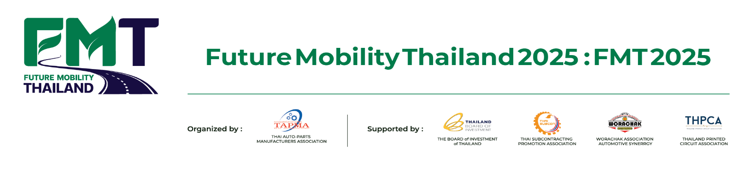**Press Release**

**TAPMA Announces the Launch of ‘Future Mobility Thailand 2025’**

*A Global Business Matching Platform Aiming to Position Thailand as a Hub for*

*Future Mobility Manufacturing*

**Bangkok** – The Thai Auto Parts Manufacturers Association (TAPMA) has officially announced the inaugural **Future Mobility Thailand 2025**, set to take place under the theme **"Driving Tomorrow: Innovating for a Sustainable and Connected Future."** This event serves as a platform to showcase the capabilities of Thailand’s auto parts manufacturers while connecting the Thai automotive industry with international partners, driving Thailand towards becoming a hub for future mobility and automotive technology.

Supported by the **Thailand Board of Investment (BOI),** Future Mobility Thailand 2025 will be held from **April 3 to April 5, 2025, at the Bangkok International Trade & Exhibition Centre (BITEC), Bangna.** This **B2B exhibition** will bring together auto parts manufacturers, electric vehicle (EV) technology developers, supply chain service providers, leading national research institutions, and investors from the global automotive industry to exchange ideas and explore business opportunities.

**Mr. Suphot Sukphisarn, Deputy Secretary General of TAPMA,** stated that Future Mobility Thailand 2025 marks a significant milestone for Thailand’s auto parts industry as it embraces emerging technologies, including **electric vehicles (EVs), hybrid electric vehicles (HEVs and PHEVs), autonomous vehicles,** and **connected vehicle technologies.**

"Thailand’s auto parts industry is well-prepared for this transformation, boasting a strong supply chain and manufacturers with the ability to adapt to new technological trends. This event presents a vital opportunity to expand into new markets, connect with global partners, and position Thailand as a key player in the future automotive industry."

Currently, Thailand is the **largest automotive and auto parts manufacturing base in ASEAN** and ranks among the **top 10 in the world,** with an annual production capacity of over **1.9 million vehicles.** By 2024, automotive and auto parts exports are expected to contribute **12% of Thailand’s GDP**, with an export value exceeding **1.02 trillion baht.**

The event’s **opening ceremony** will feature a keynote speech titled **"Adapt, Save, Create: The Future of Thailand’s Automotive and Auto Parts Industry"** delivered by **H.E. Mr. Akanat Promphan, Minister of Industry.** Additionally, there will be special presentations from industry leaders and government representatives, including **Mr. Sompol Tanadumrongsak, President of TAPMA,** and **Mr. Narit Therdsteerasukdi, Secretary-General of the Thailand Board of Investment (BOI).**

**Mr. Swaek Prakitritanon, Vice President of Foreign Affair Department at TAPMA,** highlighted several must-visit zones within Future Mobility Thailand 2025:

* **E-Parts & Mobility Revolution Zone** – Showcasing EV auto parts and cutting-edge mobility technologies that will shape the future of sustainable transportation.
* **ADAS & Entertainment Systems Zone** – Featuring **advanced driver assistance systems (ADAS)** and in-car entertainment solutions that enhance driving safety and smart connectivity.
* **BGC Green Product & Alternative Energy Zone** – Presenting **eco-friendly automotive products** and alternative energy sources aimed at reducing carbon emissions.
* **Performance Parts, Accessories, Maintenance & Car Care Zone** – Showcasing **high-performance automotive accessories, maintenance solutions,** and **advanced car care technologies** that enhance vehicle efficiency and lifespan.
* **Parts Transform Zone** – Demonstrating the **diversification of the auto parts industry** into other sectors, such as **medical equipment, aerospace, railway systems, and agriculture.**

**Mr. Swaek** emphasized that this event is a **crucial opportunity for Thai auto parts manufacturers** to strengthen their global presence, as Thailand is already an essential **global auto parts production hub** with over **1,800 manufacturers** capable of developing technologies aligned with future industry trends.

Thailand’s **auto parts supply chain** includes **1,686 manufacturers,** comprising **476 Tier 1 suppliers** and over **1,210 Tier 2-3 suppliers.** The country has a fully integrated supply chain, from raw materials to manufacturing and exports, and serves as a production base for more than **30 leading global automotive brands.**

Thailand is well-positioned to become the **leading EV market in ASEAN,** driven by rapid EV adoption, particularly with **Chinese automakers setting up production bases in Thailand.**

**"Future Mobility Thailand 2025 will be a crucial platform for Thai auto parts manufacturers to integrate into the global EV supply chain,"** Mr. Swaek stated.

In 2024, the sales of battery electric vehicles (BEVs) in Thailand are expected to surpass 100,000 units, with Chinese automakers such as BYD, NETA, and GWM leading the market. By 2030, EVs are projected to account for 30% of Thailand’s total vehicle production. Additionally, the "Japan First" policy by the Thai government aims to attract high-tech automotive investments across internal combustion engine (ICE) vehicles, EVs, and hybrids. This policy encourages the use of locally manufactured auto parts and fosters innovation in Thailand’s automotive industry.

**Ms.Siraphan On-Aht, Vice President of SMEs & Cluster Development Department at TAPMA,** emphasized the importance of **SMEs adapting to the EV and smart mobility era.**

"Currently, Thai SMEs are facing challenges in transitioning to EV production and intelligent mobility systems. Future Mobility Thailand 2025 will provide SMEs with insights into market trends, manufacturing technologies, and international business opportunities. The event will also facilitate business matching sessions, allowing Thai SMEs to engage with global automakers and technology providers, thereby expanding their international reach."

She also highlighted the importance of **upskilling the Thai workforce** to support the transformation of the auto parts industry. This includes shifting from **mechanical skills to electrical engineering expertise,** enabling the development of advanced auto parts for the next generation of mobility solutions.

To support SMEs, TAPMA, in collaboration with the **Federation of Thai Industries,** has been working on policies to help Thai manufacturers integrate into modern automotive supply chains. This includes promoting **local content requirements,** encouraging domestic production, and providing workforce training programs.

TAPMA is also committed to **supporting Thai SMEs** through **in-depth consultancy, hands-on training workshops,** and **financial support programs** to help them adapt and grow in the rapidly evolving automotive industry.

Organized by **TAPMA** with support from the **BOI, Thai Subcontracting Promotion Association, Worajak Auto Parts Association,** and the **Thai Printed Circuit Association,** Future Mobility Thailand 2025 is expected to attract **global automotive brands, importers-exporters, EV technology developers, auto parts manufacturers, and investors** looking to participate in shaping Thailand’s future automotive landscape.

For more information about **Future Mobility Thailand 2025**, please visit:  
🔹 **Official Website:** [www.futuremobilitythailand.com](http://www.futuremobilitythailand.com/)  
🔹 **TAPMA Website:** [www.thaiautoparts.or.th](http://www.thaiautoparts.or.th/)

🔹 **Public Relations:** **Duangkamon M: 099-449-7942**

###